What are Soft Skills?

Soft skills are broadly classified as a combination of personality traits, behaviors, and social attitudes that allow people to communicate effectively, collaborate, and successfully manage conflict. People with good soft skills tend to have strong situational awareness and emotional intelligence to navigate difficult working environments while still producing positive results. This is especially important for leadership positions because good leadership is more about managing people and directing their efforts toward the desired outcome rather than bringing any specific technical skills to bear.

Another benefit of soft skills in the workplace is that they help people to adapt to changing circumstances. Being able to communicate effectively during a time of uncertainty or collaborate with others when solutions aren’t immediately obvious is hugely important whether someone is in a leadership position or not. Given their many applications, it’s hardly surprising that organizations are doing more to assess a candidate’s soft skills during the interview process.

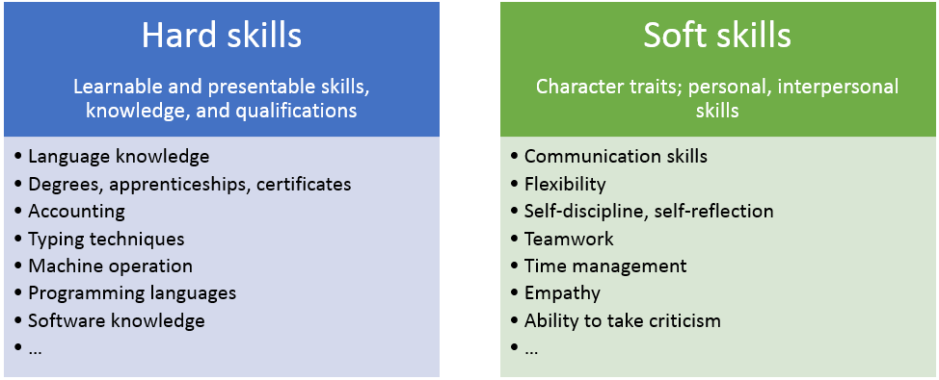

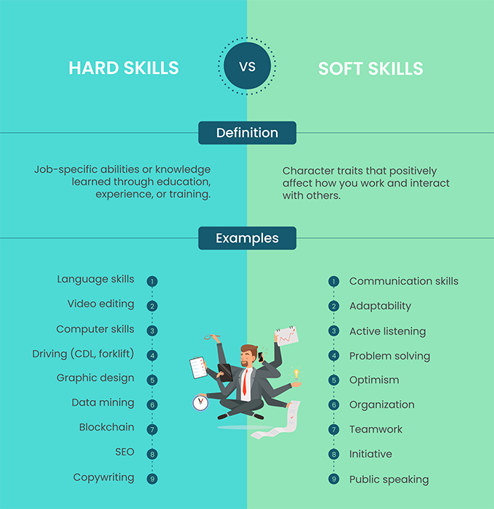

The 7 Soft Skills

1. Leadership Skills

Companies want employees who can supervise and direct other workers. They want employees who can cultivate relationships up, down, and across the organizational chain. Leaders must assess, motivate, encourage, and discipline workers and build teams, resolve conflicts, and cultivate the organization’s desired culture. Understanding how to influence people and accommodate their needs is an essential element of leadership. All too many companies overlook when they place someone with the most technical expertise in a position of authority. Soft skills development is often a key component of leadership training.

2. Teamwork

Most employees are part of a team/department/division, and even those who are not on an official team need to collaborate with other employees. You may prefer to work alone, but it’s important to demonstrate that you understand and appreciate the value of joining forces and working in partnership with others to accomplish the company’s goals. This shows that you possess the soft skills necessary to engage in productive collaboration.

3. Communication Skills

Successful communication involves five components. Verbal communication refers to your ability to speak clearly and concisely. Nonverbal communication includes the capacity to project positive body language and facial expressions.  Written communication refers to your skillfulness in composing text messages, reports, and other types of documents. Visual communication involves your ability to relay information using pictures and other visual aids. Active listening should also be considered a key communication soft skill because it helps you listen to and actually hear what others say. You need to be able to listen to understand how to best communicate with someone. Without strong listening skills, any communication efforts will be one-way and probably ineffective.

4. Problem-Solving Skills

Many applicants try to minimize problems because they don’t understand that companies hire employees to solve problems. Glitches, bumps in the road, and stumbling blocks are all part of the job and represent learning opportunities. The ability to use your knowledge to find answers to pressing problems and formulate workable solutions will demonstrate that you can handle – and excel in – your job. Discussing mistakes and what you learned from them is an important part of building a soft skills resume.

5. Work Ethic

While you may have a manager, companies don’t like to spend time micromanaging employees. They expect you to be responsible and do the job you’re getting paid to do, which includes being punctual when you arrive at work, meeting deadlines, and making sure that your work is error-free. And going the extra mile shows that you’re committed to performing your work with excellence.

6. Flexibility/Adaptability

In the 21st century, companies need to make rapid (and sometimes drastic) changes to remain competitive. So they want workers who can also shift gears or change direction as needed. As organizations have become less hierarchical and agile over the last decade, it’s more important than ever for employees to be able to handle many different tasks and demonstrate a willingness to take on responsibilities that might lay outside their area of expertise.

7. Interpersonal Skills

This is a broad category of “people skills” and includes building and maintaining relationships, developing rapport, and using diplomacy. It also includes giving and receiving constructive criticism, being tolerant and respectful regarding others' opinions, empathizing with them. This is among the most important of all the soft skills examples because it is central to building teams with a strong foundation of trust and accountability.